Project Management Application

|  |  |
| --- | --- |
| **Features** | **Description** |
| Users | Types: Admin, Project Manager, Team Member  Each user can be assigned to multiple projects and tasks |
| Projects | Created by PMs or Members  Can be of type: Paper, Book, Software App, etc.  Has many tasks  Tracked on Kanban (for members) and Gantt (for boss) |
| Tasks | Assigned to users (one or many)  Belongs to a project  Has status: To Do, In Progress, Done  Has: start date, due date, actual completed date |
| Kanban Boards | Represent tasks grouped by status for a specific user or project |
| Gantt Chart View | Admin-only view of all users’ projects and tasks over time |
| eLearning Content | Tutorials, Masterclasses, Guides, Crash Courses  Uploaded by PMs or Admins, viewable by team |
| Templates | Uploaded document templates (like Word, PDF, Excel)  Downloadable by team members |
| Analytics/Dashboard | Aggregated metrics per project, user, or team  Charts like task completion, time to complete, overdue stats |

**ER Diagram**

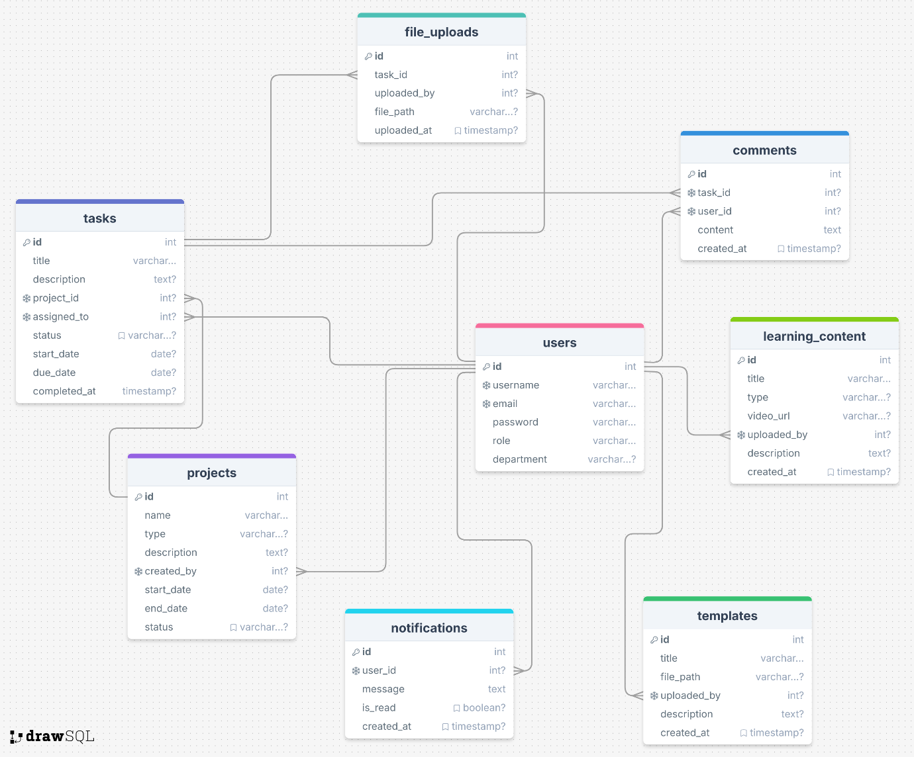

**Summary**

* One User can have many Projects, Tasks, Comments, and Files
* One Project can have many Tasks
* One Task can have many Comments and Files
* One Task belongs to one Project and one User
* LearningContent and Templates belong to a User who uploads them